1. Density depends on  - weight  - volume  - mass  - mass and volume  2. As ice cream melts, its molecules___________.  - absorb heat energy and move farther apart  - absorb heat energy and move closer together  - release heat energy and move farther apart  - release heat energy and move closer together  3. You knock your drink over in language arts. You notice the liquid spreading across the floor until it finally seeps in the carpet. Why does this occur?  - The liquid evaporated as soon as it touched the floor  - Liquids need a container to have shape  - Only the floor allows liquids to move that way  - Liquids have definite shape  4. If something has mass and occupies space, it can be defined as having what?  - Atoms  - Elements  - Solid  - Matter  5. The ________________ point is when a solid changes to a liquid. The ___________ point is when a liquid changes to a gas.  - boiling; melting  - melting; boiling  - boiling; freezing  - freezing; melting  11. Compared to gases, liquids are not easily compressed because particles of a liquid  ___________________________.  - are closer together  - are moving faster  - have more kinetic energy  - have a crystal structure  12. What are often called building blocks of matter?  - cells  - elements  - compounds  - atoms  13. An object's characteristic properties include its _________________  - mass and weight  - size and shape  - physical properties and chemical properties  - objective properties and subjective properties  14. Which of the following involves a change in physical properties only?  - baking a loaf of bread  - burning wood in a fire  - freezing water into ice  - mixing with an acid  15. Which of the following involves a change in chemical properties?  - boiling water to make steam  - a bike rusting outside  - a candy bar melting in the sun  - tearing a piece of paper to make smaller pieces of paper  20. Sarah has 100 g of each element listed in the chart below, which also provides the melting point for each element.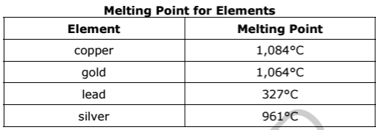  What would happen if she melted only 50 g of each element?  - The melting point for each element would double because the mass was changed  - The melting point for each element would decrease by half because the mass was changed  - The melting process would occur more quickly, but the melting points would remain the same  - The melting process would occur more quickly, but the melting points would be decreased by half | 6. All living and nonliving things are made up of a combination of ______________.  - elements  - liquids  - crystals  - oxygen  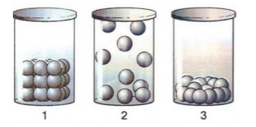  7. Which best represents the phases of water from 1 to 3?  - solid, gas, liquid  - gas, solid, liquid  - liquid, gas, solid  - gas, liquid, solid  8. What is the most common solvent?  - Air  - Nitrogen  - Water  - Fire  9. How does an increase in temperature affect solubility?  - It allows less solvent to dissolve in the solute  - It increases the amount of solute needed to dissolve the solvent  - It increases the amount of solvent able to be dissolved into the solute  - It does not affect solubility  10. In which phase of matter are the molecules of a substance farthest apart from each other?  - solid  - liquid  - gas  - crystal  17. The distance between atoms is often affected by temperature. The diagrams show water at three different temperatures.  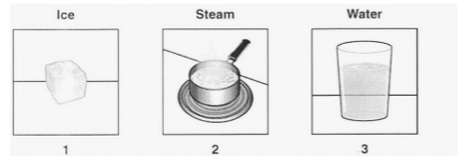  Which order of the diagrams indicates DECREASING distance between atoms?  - 1, 2, 3  - 2, 3, 1  - 3, 2, 1  - 1, 3, 2  18. An example of a property of matter that can be observed without changing the identity of the matter is:  - Oxidation  - Rust  - Combustibility  - Solubility  19. All atoms of the same element have:  - different properties  - the same physical properties  - the same chemical properties  - the same chemical and physical properties

Answer Key

1. D | 6.P.2.3
2. A | 6.P.2.2; 6.P.2.3
3. B | 6.P.2.2; 6.P.2.3
4. D | 6.P.2.1
5. B | 6.P.2.2; 6.P.2.3
6. A | 6.P.2.1
7. A | 6.P.2.2; 6.P.2.3
8. C | 6.P.2.3
9. C | 6.P.2.3
10. C | 6.P.2.2; 6.P.2.3
11. A | 6.P.2.2; 6.P.2.3
12. D | 6.P.2.1
13. C | 6.P.2.3
14. C | 6.P.2.3
15. B | 6.P.2.3
16. D | 6.P.2.1
17. B | 6.P.2.2; 6.P.2.3
18. D | 6.P.2.3
19. D | 6.P.2.1
20. C | 6.P.2.2; 6.P.2.3

