Phase Changes Study Guide (6.P.2.2) Answer Key

Phases of Matter:

Solid - Matter that has definite volume and shape. The molecules are packed together tightly and move slowly.

Liquid - Matter that has definite volume but not shape. Since the molecules are loosely packed and move with greater speed, it can flow and spread.

Gas - Matter that has no definite volume or shape. The molecules are so loosely arranged and move so rapidly that they will fill their container.

Phase Change Descriptions

Word Bank

Boiling Condensation Deposition Evaporation

Freezing Melting Sublimation Vaporization

1) The change from solid to liquid. Melting

2) The change from liquid to solid. Freezing
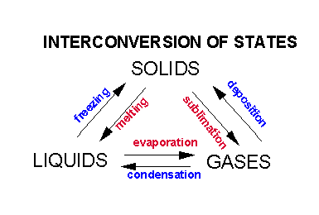
3) The change from liquid to gas. Vaporization

4) Vaporization from the surface of a liquid. Evaporation

5) Vaporization from within as well as from the surface of a liquid. Boiling

6) The change from gas to liquid. Condensation

7) The change from solid to gas. Sublimation

8) The change from gas to solid. Deposition

Phase Change Diagram - Fill in the phase changes in the blank provided.
